1)

|  |  |  |
| --- | --- | --- |
| R(x) | S | Q(t+dt) |
| 0 | 0 | Q(t) |
| 0 | 1 | 1 |
| 1 | 0 | 0 |
| 1 | 1 | x |

2) 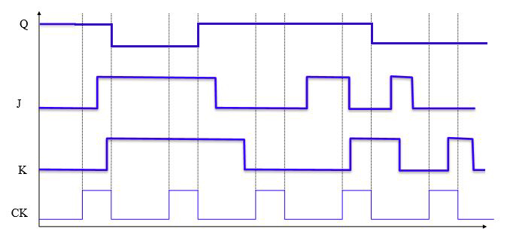

3)

State Diagram

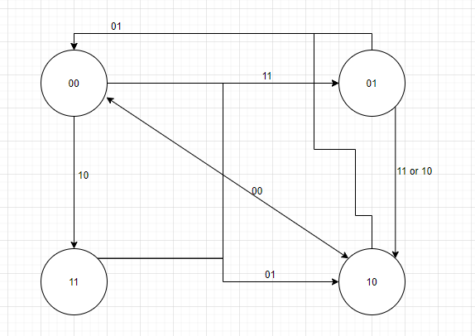

State Table

|  |  |  |  |  |  |  |  |  |  |
| --- | --- | --- | --- | --- | --- | --- | --- | --- | --- |
| X | Y | State 0 | State 1 | State 2 | State 3 | T0 | T1 | T2 | T3 |
| 0 | 0 | 10 | 01 | 00 | 11 | 10 | 01 | 00 | 11 |
| 0 | 1 | 00 | 00 | 00 | 10 | 01 | 01 | 01 | 11 |
| 1 | 0 | 11 | 10 | 10 | 11 | 01 | 00 | 00 | 01 |
| 1 | 1 | 01 | 10 | 10 | 01 | 10 | 01 | 01 | 10 |

|  |  |  |
| --- | --- | --- |
| x/y | 0 | 1 |
| 0 | 0 | 0 |
| 1 | 0 | 0 |

|  |  |  |
| --- | --- | --- |
| x/y | 0 | 1 |
| 0 | 0 | 1 |
| 1 | 0 | 1 |

|  |  |  |
| --- | --- | --- |
| x/y | 0 | 1 |
| 0 | 1 | 0 |
| 1 | 0 | 1 |

|  |  |  |
| --- | --- | --- |
| x/y | 0 | 1 |
| 0 | 0 | 1 |
| 1 | 1 | 0 |

|  |  |  |
| --- | --- | --- |
| x/y | 0 | 1 |
| 0 | 1 | 1 |
| 1 | 0 | 1 |

|  |  |  |
| --- | --- | --- |
| x/y | 0 | 1 |
| 0 | 1 | 1 |
| 1 | 1 | 0 |

T0x= x’y’ + xy T0y= xy’ + x’y T2x= 0 T2y= y

|  |  |  |
| --- | --- | --- |
| x/y | 0 | 1 |
| 0 | 0 | 0 |
| 1 | 0 | 0 |

|  |  |  |
| --- | --- | --- |
| x/y | 0 | 1 |
| 0 | 1 | 1 |
| 1 | 0 | 1 |

T1x= 0 T1y= x’ + y T3x= x’ + y T3y= x’ + y’

Sequential Circuit

